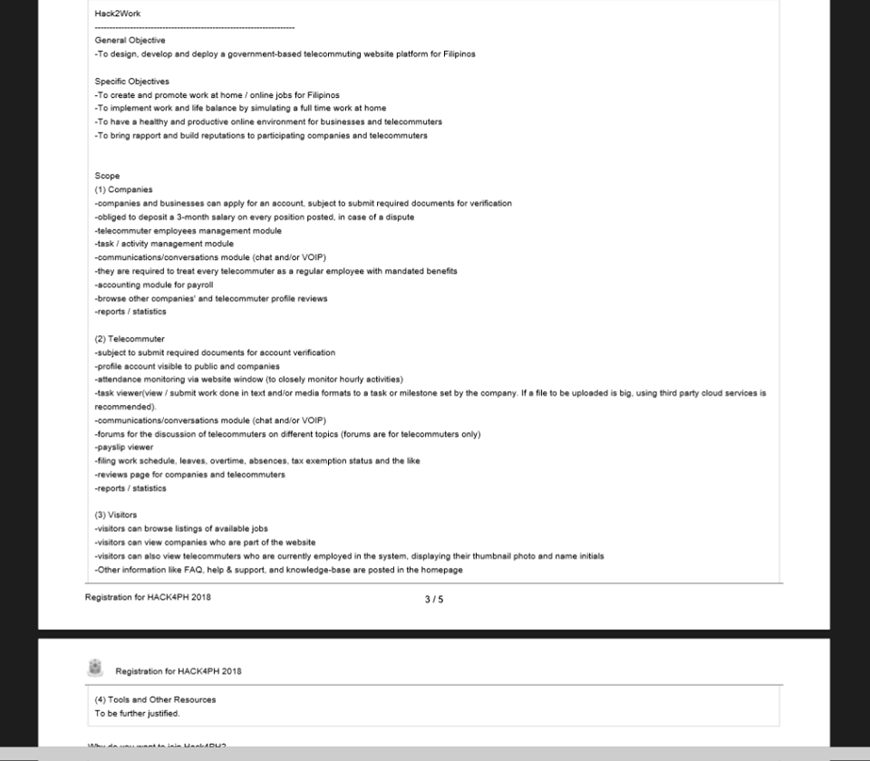

Design, deploy and develop an windows application to monitor the employee movement in their workstation while working at home.

- Allow Employer/Manager to view the application visited by the employee

- Take random screenshot during working hours.

- Allow Employee to log task during the working hours

**insights**

mysql sana kung pwede un nalang gamitin mong library as database para pwede maginstall si dict nalang ng linux server tapos ung winforms mo to be downloaded nalang ng mga end clients..dun sila magtransmit papuntang server ni dict

what we need here is a solution for TELECOMMUTING (work from home). we need to build a platform to support work at home jobs.

if you guys are familiar with upwork or freelance.com sites, thats what we need. im a freelancer myself and used this tools for years

basically all components are web based, joseph will take care of the remote desktop app.

other teams, will be using mobile and php frameworks according to my research..one team will use laravel which is the current trend, however the eloquent orm component will require more server processing memory. I think using a fast framework like codeigniter will give us an advantage..since the goal is to prpduce a working prototype, we will focus on the functionality rather than the ui design. Shanelle could use bootstrap css since most govt sites are made from it. Our competitors will have mobile apps, i can create android apps but we cant make it on time because web is a big task..we will make mobile responsive web design instead..this will be very feasible, i also think other teams will use the same idea hence we shpuld also think of an out of the box functionality too

.is it okay if we prefer ci? Having used both laravel and ci, still i chose ci for simpliness and great mobility.

Can you build installer packages from winforms? You could study how upwork desktop app and timedoctor works because we need to clone those type of software. Maybe you could further how we could integrate real time chat with mysql as the db server, also how to upload/download to and fro the web server..how should we do this? By post request or ftp?and finally the winning edge of implementing voip or video sharing(advanced)

I also need those functionality in the web..the only voip andd real time conferencing is by the use of third party which is a no no..need to learn thos hings too

*the only way i know to implement voip is by third party app.

we have no options for the voip other than twilio. our system will need twilio to handle communications. it offers free trial so maybe we could take advantage from it

we will focus on a 2 day timeline..only saturday and sunday..the few hours left on the 3rd day will be used on improving and latter patches.. we have a very limited time est. 20 active coding hours to build a prototype, let us not

consume time of what to do. upon our initial meetup, we can hold an hour of meeting of our final briefing before we step into different individual tasks

DAY 1: please expect a delay on day 1 as organizers or the program will start late so we will have hours less

we will make strong efforts to consume at least 10 hours of coding time each day, we also needed the sleep and a soundful rest to be able to think great ideas

dustin -will start on the web forms and APIs

@Joseph - will make the winform apps and basic pages with functionalities. will try to create transport of files module from in and out of the server

@Shanelle - (if you already studied twilio or govph's common platform) can start with creating and testing the video conferencing functionality using php

DAY 2:

dustin and @Joseph will collaborate on implementing the winform app as a remote employee desktop app

dustin - will add the task messaging part of the web.(inbox/outbox) type.

joseph - will make the said function to the winform with desktop notification e.g. popup sound

@Shanelle Recheta and dustin will also collaborate implementing the voip if possible to integrate to the system

rest of the time here will be consumed

From upload/download: if we want to upload or download we can do a post request for smaller file and ftp for bigger files.

Suggestion about sa mobile: maybe they can use react native since it can be a cross platform

un nga nasip ko kaso were handful with tasks already.. ako sa web ikaw sa winform, para kasing we have no time for xplatform devt..

un nga nasip ko kaso were handful with tasks already.. ako sa web ikaw sa winform, para kasing we have no time for xplatform devt..

nakaattach sa setup installer ng winform mo ung ftp, keri ba un? d ba sya threat or hackable?

this planning is beneficial para pagdaitng ng event, buhos natin ung prepared nating plan

un lang di sya restful.. kasi pag pinush natin si twilio, may sms na tayo at calls..which is the lowest price out there..

ang plan b natin jan, chat nalang communication natin 😀 haha may skype naman at messenger e...ang importante lang is the reporting ng employee of tasks, ung pagupdate nya kay employer

importante din na may winform to take random interval screenshots from remote worker

un lang para finish na hahah... we need to establish first our business model, dun sila mapawow

ang alam ko sa hackaton is we build protoypes.. its only a 2 day event ang importante, the idea is there for them to appreciate..our product will be their sneak peak lols

meron din project mgmt tool si govph common platform

madugo if sarili natinng trello hahaha..un nga sana gusto ko.. pwede naman natin gawing simple like ung flow ng upwork and freelancer.. mejo general purpose ung system natin.. non programming jobs will also be there like encoding and simple online tasks, importante talaga na mamonitor ung activity nila hindi ung puro sila facebook hehe

simplehan natin hanggang maari ung prototype natin para madami tayo magawa…

we rely on the internet

pwedeng magtext ng parameters si employee about a task to update the milestone at hand

[Sample]

EMPLOYEECODE (space) COMPANYCODE (space) TASKCODE (space) MESSAGE and send it to 22222222223

useful yan halimbawa outdoor task si employee.. halimbawa ung mga nagsusurvey etc…

They can work offline also, tpos if may internet access na. They can upload theyre logs? Pero if mag WFH, dpt tlga may internet, worst case scenario if no internet gnyn mangyayari

save as local file muna tapos upload dun sa web..nakaretain din ung timestamps nya

may scenario dn siguro na magaasign lang si employer ng selected reporting dates para magreport to work si employee..dun nya makikita... para kahit not everyday online si employee...

example nagusap sila na thursday and friday magchecheck si employer, tapos sched ni employee is mon-fri...kahit di na magonline si employee ng mon at tuesday, sa wednesday nalang sya ulit magconnect para magupload ng work nya online

okay siguro joseph na may sarili kang file type ng export nung logs containing chats and files..para if halimbaha walang internet sa bahay si employee, pwede nya iupload ung file mo sa compshop

We can do full http request only, i think di nman magdodownload ng sobrang laking files mga employee?

For the offline files, i think dpat kng san nya gnwa ung tasks nya dun pa dn. confidential purpose lng dn so need nya tlga iconnect ung laptop nya sa internet? Pde ksing mangyari if sa compshop is maforgot ung offline file then macompromise ung laman.

kaya nga you need to have your own filetype and file name.. example "logsmsjw22h0357.seph" ang iuupload nya..

compressed screenshots at text (chat) lang naman nun

Pra maupdate lng si boss

di na kasama ung mga inupload nilang mga pics or other figures

uu...para masama pa din dun sa work log nya

Tried upwork, few times. Kelangan natin ng scope ano ano yung mga features needed. Mala upwork ba yyng gagawin natin? May rates and submit proposal/resume din n parang linkedln simplified. Then meetings and timelog/ screenshot capture.

yup mala ganun nga po.. joseph is in charge of the desktop app for timelog and ss

mejo malaki ung scope pero we need to compress it into 2 days

wala tayong fixed rate like upwork..di rin tayo hourly but daily ang usapan... and minimum job contract time is 6 mos siguro.. ang payment ang naisip ko sila na bahala magpasweldo para wala masyado trabaho ang govt, ang task lang ng system to ensure all salaries are remitted to employees..

pero initially ang naisip ko dito is magkaroon ng escrow service like upwork kaya lang it will take a long time di aabot sa hackathon..magoopen ng account sa bpi then meron silang api to manage that account though di ko pa ito naeexplore thoroughly..also building our own escrow service will also have legal arrangements.pero if ipush ito at magkaroon ng govt funding, hayahay to

we will have an employee protection here wherein a company will require a refundable deposit of X mo.(s) in case a dispute arises with both parties

so pinakabasic lang,

EMPLOYER MANAGEMENT

EMPLOYEE MANAGEMENT

TASK MANAGEMENT(TASKS OR ACTIVITY LOGS/CALENDAR)

ATTENDANCE LEDGER / FILING OF SL,VL,ETC

POLICIES AND MANUAL

PAYSLIP/PAYROLL (HRIS)

REPORTS(ANALYTICS/PERFORMANCE ETC)

Kung magtwilio tayo, pandagdag ng functionality like voip or sms..pero siguro pwede din wala nun kasi meron namang teamviewer, anydesk, other tools. importante lang talaga merong official system which is legal, reliable and strong na magmonitor ng relationships between the employer/employee.

keep in mind that bahala na si employer magpadala ng pera, imomonitor lang natin if accepted ni employee.. ipupush kasi natin na magkaroon ng mandatory benefits si work at home employee kagaya ng regular workers

mejo simple, oo... as in.... super in general. super duper common na. other teams will also get that impression to create the similar..pero if we could do this properly, maybe meron tayong pangnochebuena 😀 please lang, LIBRE LAIT, LIBRE COMMENT, NO HARD FEELINGS 😀 😀 😀

if you have a more feasible and more realistic to build in under 2 days or 20 hours, it would be great. the goal is to build a working prototype not a fully furnished one. winning ideas please

im dustin on the web, also need your help to this on most parts

mr. joseph is on the desktop app, also could help on the website with me

ms shanelle can do research, study twilio for integration, the enhancement on the front end, documentation

ms frances can you do android from java? can do torture tests and last minute dry runs for the web and winform app

ms shanelle and ms frances can brainstorm for more possible ways on how to get things don in time while me and joseph is on the ground coding

*this is only my suggestion, we can agree on your plans.. please open up.. ill use codeigniter for the project

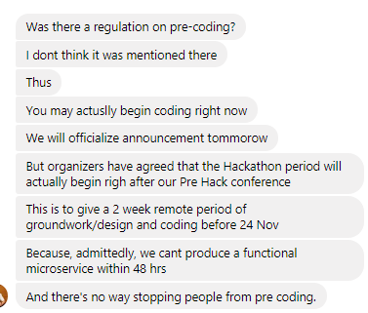

are you available to allot some little time to test your winapp connectivity to an online server? how will you do it? do you need an api service, what method? or do you need db credentials? ill provide the live staging site

I dont think we need api service or any method to connect it online. I will develop it first local and after doing some test Ill just change the credentials, so db credentials would be fine

we have 2 options:

1. using an online hosting. its cheap and it would be easier if all data is already online

2. using a local server using your sql server database. BUT you must need to have a static ip to make it live. i think we cant do this because its expensive and difficult to maintain. I have done this before on my past projects.

cant afford that static ip

you cant also move your network with static ip when you go from place a to be

-pick option 1

start with the winform app connecting to an online database

just tell me what you need to access the online db.. i was also wandering how will you put files from local to live...siguro bro para hindi tayo mahirapan sa part ng uploading and downloading media files, baka pwedeng ibase64 nalang tapos decode on the oother side? vice versa

ok i already acquired a domain and a host

Clarify ko lng, So I will create a winform app na iinstall sa employee, then this app will connect to our databse to upload/download some data.

can we create a repository for the documentation?

do you have experience in codeigniter? or should we guys use the native php from scratch, para mabilis ang devt?kaya lang gagawa tayo ng sarili nating classes from scratch

ill also create a database schema later so you have a guide

let us eliminate or minimize comparin our work to other team. let nothing demotivate you from achieving our goal. we dont have to dig deep, all we need is a CONSISTENT little efforts to get this done. Goodluck Team 1A

kaya mo ba gawan na ng db fields or erd ung gagawin mong part? para maimerge din sa gawa ko

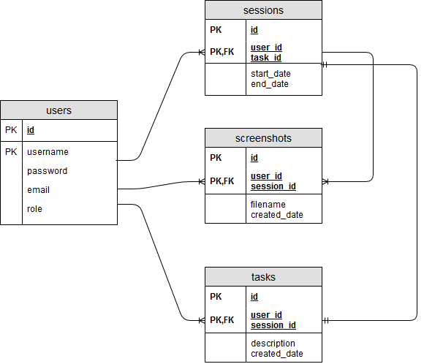

screenshots, timer, tasks, messaging kahit chat refresh lang every second

saka na ung voip

pag nasetup na natin lahat ng base components

ung timer, equal na sya dun sa sessions?

may tasks n dn incorporated dun sa s sessions

messaging n lng idagdag ko sa erd

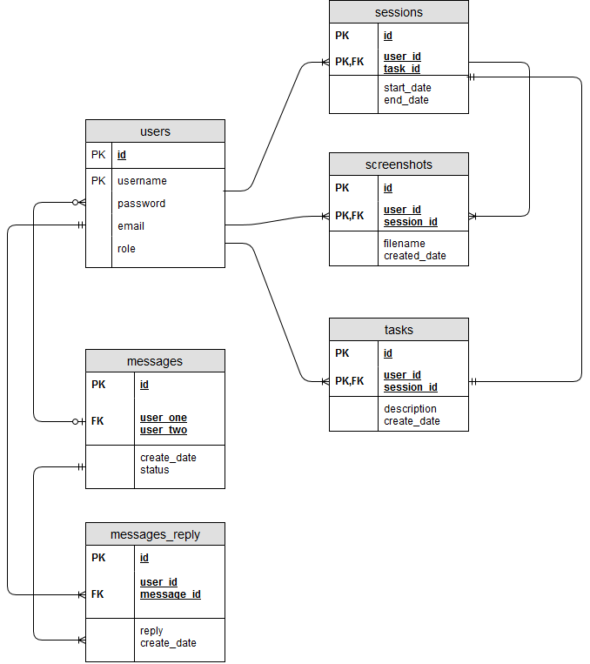

here's the initial erd, to be continued tomorrow tapos simulan na natin sa software

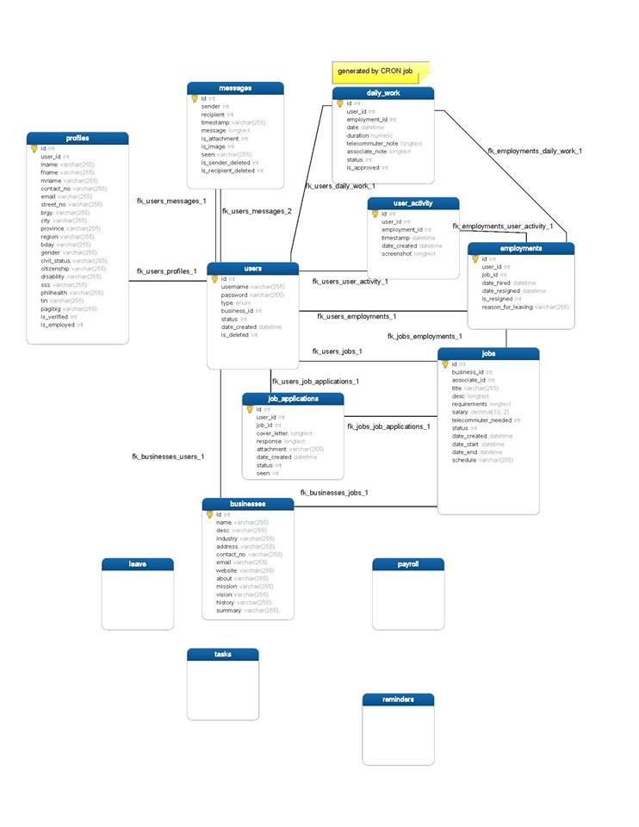

please study guys. paroll call naman sa inyong lahat ano na po ung sisimulan nyong gawin? we need to have the layout and minor functionailty before event sana para di tayo magahol..mejo malaki kasi sya

ako tatapusin ko lang tong erd, sisimulan ko na itong web icode

noted..please see if we could pull in and out records from db

do you have an api for user login?

for the mean time @Joseph please work on the other non-db modules

Copy. Try ko muna dummy user login. Thanks.

Eto ung initial design ko po for the desktop app, sorry di ako msyadong magaling sa design.

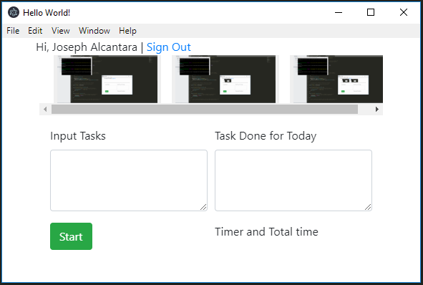

**Apps we could integrate**

Trello (govt offices will be more efficient if they started to operate like startups - doing much more work in much less time) - use the Agile/Scrum principles in the workplace - make it visual and transparent to all members

http://www.trello.org/help.html

Upwork

Freelance.com

GoToMeetings (for online conference calls)

oDesk

API summary

**Database**

Winforms (client app), sql server ,ms access, mariadb, timedoctor, codeigniter, laravel, twilio, php, restful, jobstreet / linkedin + upwork, native php, html, js, css, electron, c# .net, github, navicat, itexmo

semaphore.co rin if ever .5/txt